# LAB 7: Linear Programming Problems

**THEORY:** Linear programming deals with complex optimization problem. The problem is modelled as linear function which has to be optimised subject to various constraints expressed as inequalities. The function which has to be optimised is called the objective function. Such problems arise in industry where resources are limited and one has to use it in a best possible way.

**Ex. 1:** A paint manufacturer produces two types of paint, one type of standard quality (S) and the other of top quality (T). To make these paints, he needs two ingredients, the pigment and the resin. Standard quality paint requires 2 units of pigment and 3 units of resin for each unit made, and is sold at a profit of Rs1 per unit. Top quality paint requires 4 units of pigment and 2 units of resin for each unit made, and is sold at a profit of Rs1.50 per unit. He has stocks of 12 units of pigment, and 10 units of resin. Formulate the above problem as a linear programming problem to maximize his profit and solve it using graphical method and *Solver*.

**Solution:**

* Initially covert the problem into mathematically.

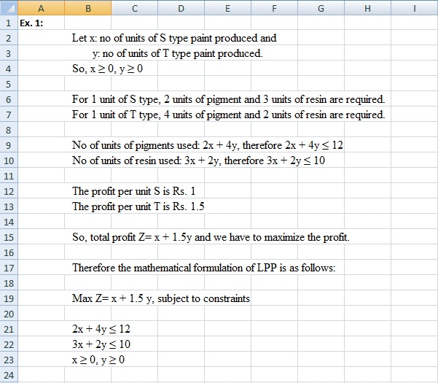

**Fig. 7.1.1**

* Tabulate the objective function and the constraints

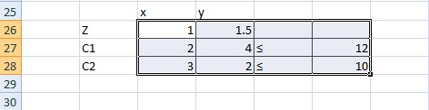

**Fig 7.1.2**

* Consider C1. By putting *y* = 0, we get *x* = 6 and by putting *x* = 0, we get *y* = 3. Similarly, consider C2. By putting *y* = 0, we get *x* = 10/3 and by putting *x* = 0, we get *y* = 5. This can be tabulated in excel as shown in the Fig 7.1.3 Note that before dividing in excel select the cell, right click and then select format. In format, select data type as numbers and also you can fix the numbers after decimal.

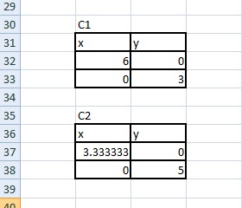

**Fig 7.1.3**

* Select the data in C1 and then select insert tab, choose straight line in scatter plot as shown in the Fig 7.1.4

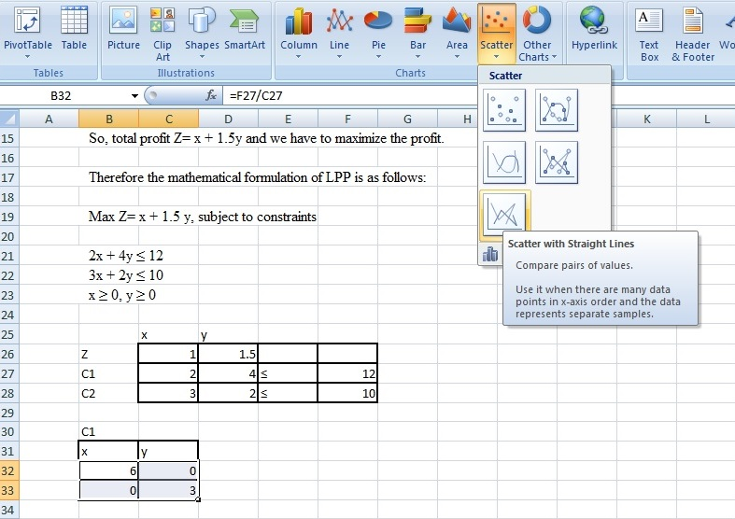

**Fig 7.1.4**

* After plotting the graph, right click anywhere on graph and choose select data. Click on series 1 and choose edit. For series name, type C1. In series X, delete the entries and select the data under x in C1 and similarly for y. Then click Ok. Again click add. For series name, type C2. For series X, choose data under x in C2. For series Y, choose data under y in C2. Then in the graph insert TEXT BOX and name the lines as C1 and C2.

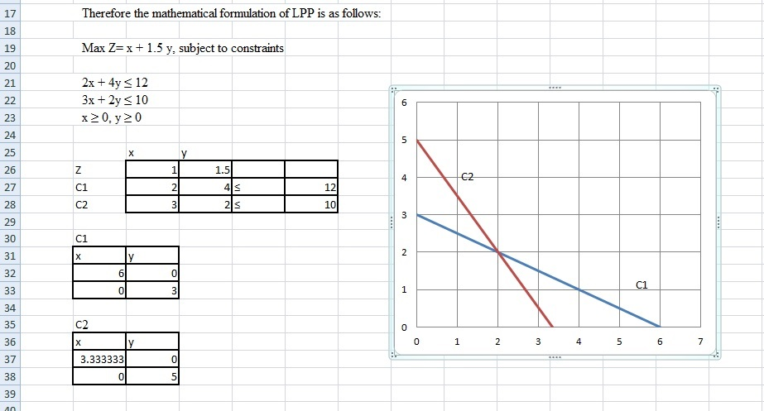

**Fig 7.1.5**

* To find the feasible region note that x≥0, y≥0. This implies the feasible region is in the first quadrant. Similarly, by putting x=0 and y=0, the inequality in C1 is satisfied so the region is below C1 line. By putting x=0 and y=0, the inequality in C2 is satisfied so the region is below C2 line. This can be shown in the graph by inserting arrows as shown in the Fig 7.1.6

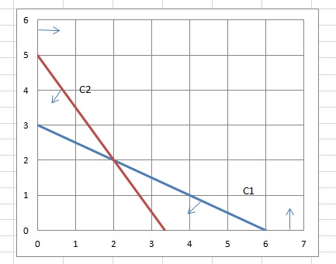

**Fig 7.1.6**

* The feasible region is nothing but the common region as shown in the Fig 7.1.7. To shade the region, insert shapes and from shapes select freeform and move along the edges of the region. Insert a text box and label the region as feasible region. Label the edges.

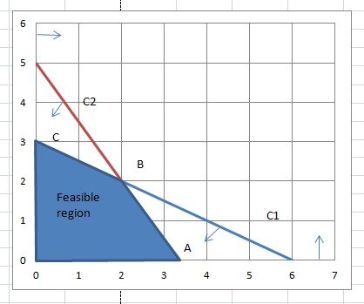

**Fig 7.1.7**

* To find the co-ordinates of A, make a table with coefficients of x and y in the equations of lines which intersect at A.

|  |  |  |  |
| --- | --- | --- | --- |
| point A |  |  |  |
| X | Y |  |  |
| 1 | 0 | = | 0 |
| 3 | 2 | = | 10 |

* Then values of x and y are obtained using functions MMULT and MINV and press CTRL+SHIFT+ ENTER,. Then find value of Z at A by putting values of x and y at A.

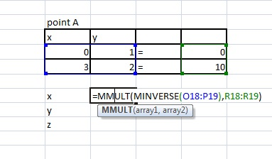

**Fig 7.1.8**

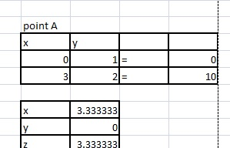

**Fig 7.1.9**

* Similarly, we can find co-ordinates B and C.

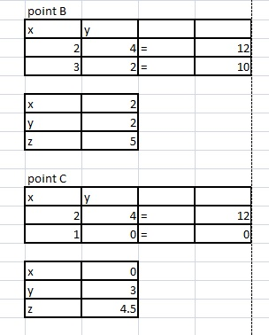

**Fig 7.1.10**

* Clearly, Z is maximum at B. Therefore (x, y) =(2, 2) gives the maximum, i.e. by making 2 units of S type and 2 units of T type gives maximum profit of Rs. 5/-

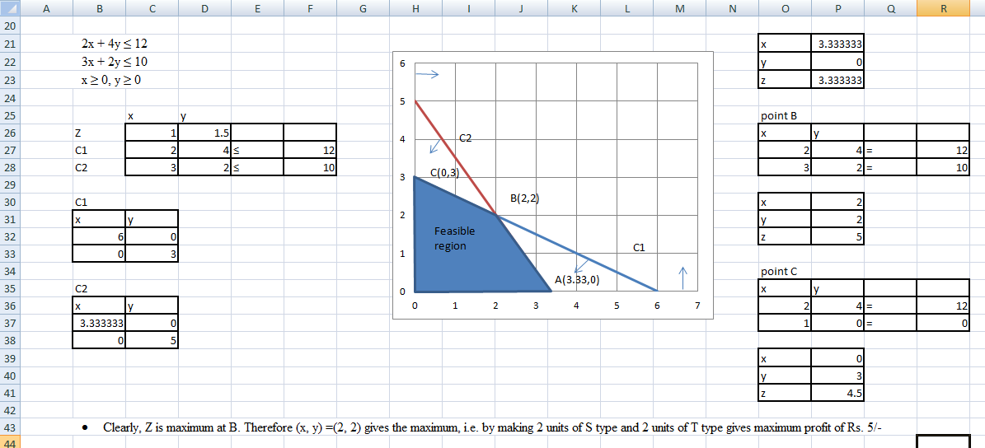

**Fig 7.1.11**

PROCEDURE FOR SOLVER:

* Identify the decision variable. Here it is the number of units of S type paint and the number of units of T type paints.
* Make a table of given information with respect to the decision variables. In this case S type paint and T type paint with number of units of pigment resin required as shown in Fig 7.1.12.

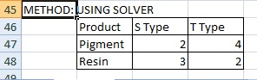

**Fig 7.1.12**

* Make a table with the decision variable and their contribution

|  |  |  |  |
| --- | --- | --- | --- |
|  | S type | T type | Total |
| Decision var |  |  |  |
| Contribution | 1 | 1.5 |  |

Leave the cell corresponding to number of S type and T type paint empty. In row corresponding to contribution, profit per unit has to be entered.

* To compute total contribution, type=(select cell corresponding to contribution of S type )*( select cell corresponding to number of units of S type)+ (select cell corresponding to contribution of T type )*( select cell corresponding to number of units of T type), press ENTER.
* Enter the constraints. That can be done by entering information regarding no of units of pigments and resins required below the contribution.
* In the column of Total, corresponding to pigments write the formula for total number of pigments needed in terms of decision variable and the required quantity which is =(select cell corresponding to pigments required for per unit of S type )*( select cell corresponding to number of units of S type)+ (select cell corresponding to pigments required for per unit of T type )*( select cell corresponding to number of units of T type), press ENTER.
* Similarly for resin, type=(select cell corresponding to resin required for per unit of S type )*( select cell corresponding to number of units of S type)+ (select cell corresponding to resin required for per unit of T type )*( select cell corresponding to number of units of T type), press ENTER
* Now total number of pigments and resins are to be entered in a column next to Total with title Max. (See Fig 7.1.13).
* Now we go to *Solver.* In the top panel of Excel sheet select tab Data. In that right hand corner *Solver* option is there. Select it. (See Fig 7.1.14).

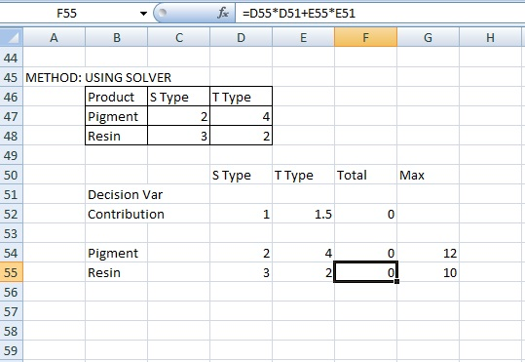

**Fig 7.1.13**

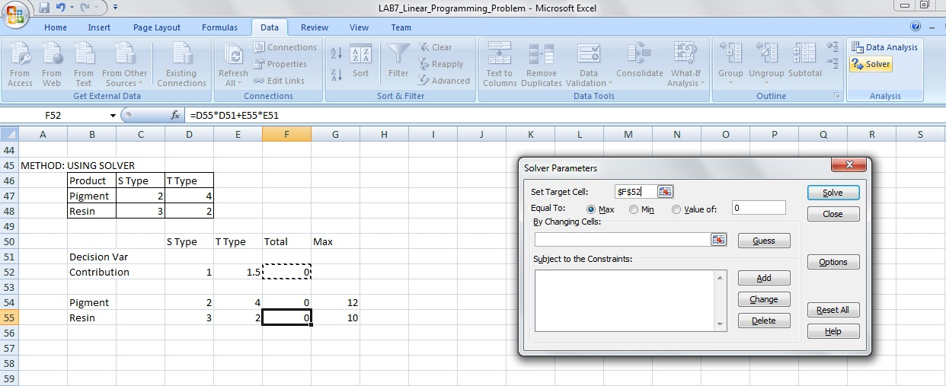

**Fig 7.1.14**

* In option Set Target Cells, select cell corresponding Total Contribution.
* Since we need to maximize, in option Equal to, select Max.
* Changing cells are nothing but the decision variables, so select the cells in the row of decision variable under S Type and T Type.
* To add constraints, select add and we get another pop up table as shown in the Fig 7.1.15

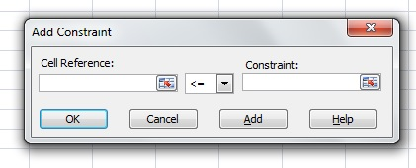

**Fig 7.1.15**

* In cell reference, select the cell under total corresponding to the first constraint (pigment).
* In constraint, select the cell under Max corresponding to the first constraint (pigment) and then press Add to add second constraint.
* In cell reference, select the cell under total corresponding to the second constraint (resin).
* Again in constraint, select the cell under Max corresponding to the second constraint (resin) and then press OK as there are no more constraints. Again the previous window pops up with added constraints.
* Press OPTIONS. Then a window pops up as shown in the Fig 7.1.16

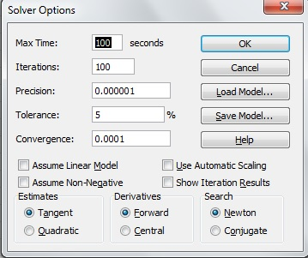

**Fig 7.1.16**

* Select Linear Model. Also since the units cannot be negative, select Assume Non-Negative. Then press OK. Then the previous pop up table comes.
* Select Solve. Then in next pop up table press OK. The solution is obtained in the columns of decision variable. We can see that in the Total contribution we also get the maximum value.

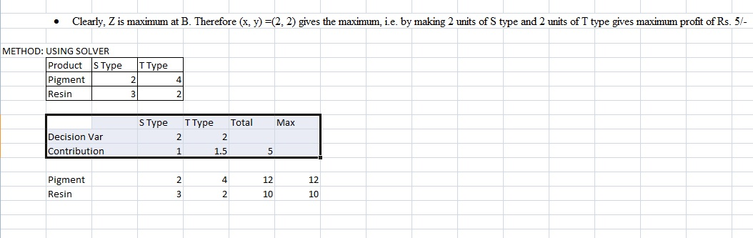

**Fig 7.1.17**

**Ex. 2:** Old hens can be bought at Rs. 20 each and young ones at Rs. 50 each. The old hens lay 3 eggs per week and the young ones lay 5 eggs per week, each egg worth Rs. 3 each. A hen (young and old) cost Rs. 10 per week to feed. Ira have only Rs. 800 to spend for hens, how many of each kind should Ira buy to give a profit of more than Rs.60 per week, assuming that Ira cannot house more than 20 hens. Solve graphically.

**Ex. 3:** The standard weight of a special purpose brick is 5 kg and it contains three basic ingredients B1, B2 and B3. B1 costs Rs.5 per kg and B2 costs Rs. 8 kg per kg and B3 costs Rs 4 per kg. Strength considerations state that the brick contains not more than 3 kg of B1 and not more than 1 kg of B3 and minimum of 2 kg of B2. Since the demand for the product is likely to be related to the price of the brick. Find out minimum cost of the brick satisfying the above conditions. Use *Solver.*